BUSINESS INSIGHT REPORT
DATASET
Global Sales & Financial Performance
PREPARED BY
K MAHENDRAN

2. Introduction
This report presents a business insight analysis of the Global Sales & Financial Performance dataset, drawn from an interactive Power BI sales dashboard covering the period 2018 to 2024. The purpose of this report is to translate the dashboard's key metrics into a clear narrative of business performance — summarizing overall sales and profitability, evaluating how different product categories, months, regions, and employees have contributed to results, and using these findings to propose practical, data-driven recommendations. The intent is to give stakeholders a concise, decision-ready view of where the business is performing well and where opportunities for improvement exist.

3. Dashboard Overview
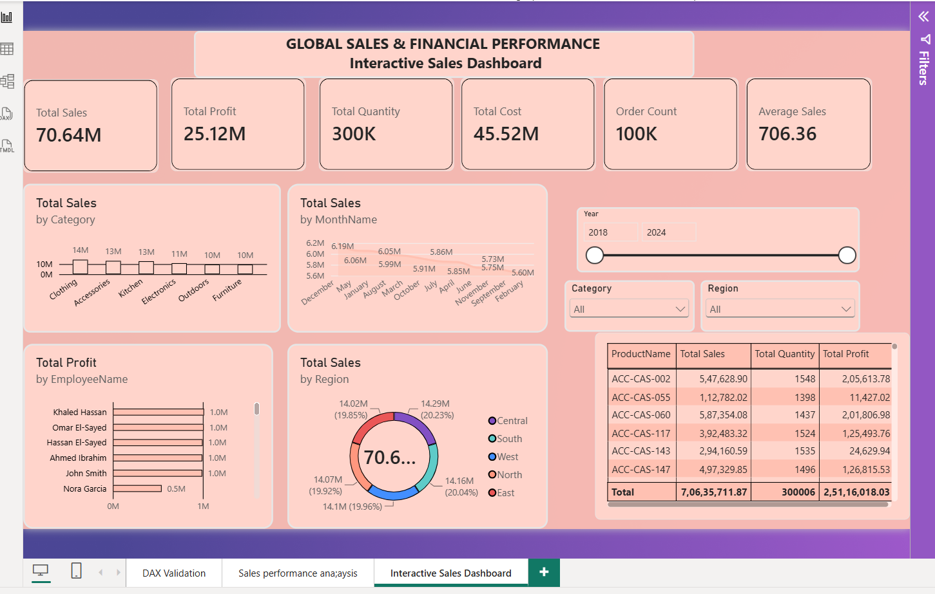
The Interactive Sales Dashboard consolidates the organization's global sales and financial data into a single view. It displays six headline KPI cards (Total Sales, Total Profit, Total Quantity, Total Cost, Order Count, and Average Sales), alongside visual breakdowns of sales by product category, by month, by region, and profit by employee, plus a detailed product-level table. Slicers for Year, Category, and Region allow the data to be filtered interactively, making the dashboard a flexible tool for both high-level monitoring and drill-down analysis.

4. KPI Analysis
The dashboard's core KPIs summarize overall business scale and profitability:

TOTAL SALES  $70.64M | TOTAL PROFIT  $25.12M | TOTAL QUANTITY  300K
TOTAL COST  $45.52M | ORDER COUNT  100K | AVG. SALE VALUE  $706.36

- Total Sales of $70.64M against a Total Cost of $45.52M yields a Total Profit of $25.12M — an overall profit margin of approximately 35.6%, indicating healthy underlying profitability.
- 300K units were sold across 100K orders, giving an Average Sale Value of $706.36 per order, suggesting a business model weighted toward higher-value transactions rather than high-frequency, low-value purchases.
- With cost representing roughly 64% of sales, there is measurable room to improve margin further through procurement, discounting discipline, or product mix optimization.

5. Product Category Performance Analysis
Total Sales by Category shows a fairly balanced spread across six categories, with a modest lead for lifestyle-oriented products:
Category | Approx. Total Sales | Relative Position
Clothing | $14M | Highest performer
Accessories | $13M | Strong performer
Kitchen | $13M | Strong performer
Electronics | $11M | Mid-tier
Outdoors | $10M | Lower tier
Furniture | $10M | Lower tier

Clothing, Accessories, and Kitchen together account for the majority of sales, while Outdoors and Furniture trail behind the top categories by roughly 4M each. The spread is not extreme, meaning the business is not overly dependent on a single category, but Furniture and Outdoors stand out as areas where targeted promotion or assortment review could close the gap with top performers.

6. Monthly Sales Trend Analysis
Monthly Total Sales are relatively stable across the year, ranging from roughly $5.6M in the lowest month to about $6.2M in the strongest month — a variance of only around 10%. December stands out as the strongest month, likely reflecting seasonal/holiday demand, while February is the softest month for sales. The narrow spread between peak and trough indicates a business with a fairly consistent, low-seasonality demand pattern rather than sharp spikes and troughs, which supports predictable inventory and staffing planning throughout the year.

7. Regional Sales Analysis
Sales are distributed almost evenly across the five regions — Central, South, West, North, and East — with each region contributing close to 20% of Total Sales (approximately $14.0M–$14.3M per region). South leads marginally at roughly 20.2% of sales, with Central slightly the lowest at around 19.85%.
This even distribution suggests a mature, well-diversified geographic footprint with no single region carrying disproportionate risk or reward. It also means growth initiatives can be tested regionally without materially skewing overall results, and that any region-specific issue (e.g., in Central, the lightest performer) has only a small drag on the total.

8. Employee Performance Analysis
Total Profit by Employee shows five employees — Khaled Hassan, Omar El-Sayed, Hassan El-Sayed, Ahmed Ibrahim, and John Smith — each contributing approximately $1.0M in profit, a tightly clustered and consistent group of top performers. Nora Garcia contributes notably less, at approximately $0.5M, roughly half the profit of the leading group.
The tight clustering among the top five suggests consistent performance standards or comparable territory/account sizing across most of the team. Nora Garcia's gap is the clearest individual outlier in the dataset and warrants a closer look — whether due to account/territory size, tenure, product mix, or a coaching opportunity.

9. Business Recommendations

Inventory Planning
- Maintain higher stock buffers for Clothing, Accessories, and Kitchen given their consistent demand, while right-sizing inventory for Furniture and Outdoors to avoid overstock.
- Build modest seasonal stock-up for December and scale back slightly heading into February to match the observed monthly trend.

Marketing Strategy
- Run targeted promotional campaigns for Furniture and Outdoors to lift their sales closer to the top-performing categories.
- Use December's natural demand peak as an anchor for holiday campaigns, and introduce demand-generation promotions in the softer February period.

Regional Expansion
- Because performance is already balanced across all five regions, prioritize incremental investment in the South (current leader) to compound strength, while investigating whether Central's slightly lower share reflects an addressable gap (e.g., distribution, staffing, or local marketing) or a genuinely smaller market.

Employee Performance
- Study the practices of the five ~$1.0M-profit performers and formalize them into a playbook or coaching program for the wider team.
- Provide Nora Garcia with targeted support — mentoring, account review, or territory rebalancing — to close the roughly 50% profit gap versus the top group.

Product Portfolio
- Review the Furniture and Outdoors ranges for pricing, assortment breadth, or product-quality issues that may be limiting sales relative to other categories.
- Consider bundling lower-performing categories with top sellers (e.g., Kitchen with Furniture) to lift attachment rates.

Customer Targeting
- Leverage the high Average Sale Value ($706.36) to build a loyalty or upsell program aimed at existing high-value customers rather than solely pursuing new low-value order volume.
- Use category and regional performance data to segment customers and personalize offers, particularly to drive incremental demand in weaker categories and the softer February period.

